ORDERS MANAGEMENT SYSTEM

ASSIGNMENT 3

NUME STUDENT: Voicu Sara-Ioana
GRUPA: 30421

CHAPTERS

1. Objectives 3
2. Analyzing the problem and User-Cases 3
3. Design 4
4. Implementation 8
5. Results 10
6. Conclusion 11
7. Bibliography 11

Objectives
The main purpose of this project is to design and implement an orders management system for processing client orders for a warehouse. Relational databases should be used to store the products, the clients, and the orders.
Other sub-objectives are:
- Analyzing the problem and requirements
- Designing the graphical interface of the application
- Implementing each task that the user can do
- Connection the application to a database where we can store and update the data

Analyzing the problem and Use-Cases
Analyzing the problem:

The user can access 3 different graphical interfaces. For the client one we have a table with data about the client, which we can delete, add or modify. For the product and order the user can do the same tasks as for the client interface, but can also place an order. We modify the stock for our products each time we place or delete an order.
The application should be designed according to the layered architecture pattern and should use (minimally) the following classes:
• Model classes - represent the data models of the application
• Business Logic classes - contain the application logic
• Presentation classes – GUI related classes
• Data access classes - classes that contain the access to the database

Modelling the problem:

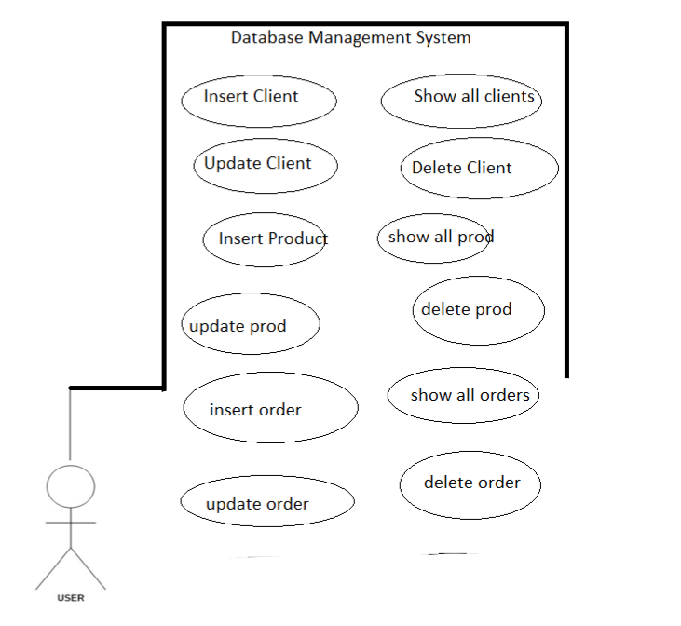

Use Case 1: add, delete and modify a client
Primary Actor: user
Main Success Scenario: the user is able to add, modify or delete a xlient. He/She is supposed to add an id, a name and an email address for the client for the add operation. When the user deletes the client, he/she must only introduce the id of the client that is going to be deleted.

Use Case 2: add, delete and modify a product
Primary Actor: user
Main Success Scenario: the user is able to add, modify or delete a product. He/She is supposed to add an id, a name, a price and a quantity for the product for the add operation. When the user deletes the product, he/she must only introduce the id of the product that is going to be deleted.

Use Case 3: add, delete and modify an order
Primary Actor: user
Main Success Scenario: the user is able to add, modify or delete an order. He/She is supposed to add an id, select an already existing client, select an already existing product and insert the quantity that the client wants to order for the add operation. When the user deletes the order, he/she must only introduce the id of the order that is going to be deleted.

Use Case 4: generate a bill
Primary Actor: user
Main Success Scenario: the user is able to generate a bill with all the details about the order that he/she made.

Design
A Layered Architecture, as I understand it, is the organization of the project structure into four main categories: presentation, application, domain, and infrastructure. Each of the layers contains objects related to the particular concern it represents.
- The presentation layer contains all of the classes responsible for presenting the UI to the end-user or sending the response back to the client (in case we’re operating deep in the back end).
- The application layer contains all the logic that is required by the application to meet its functional requirements and, at the same time, is not a part of the domain rules. In most systems that I've worked with, the application layer consisted of services orchestrating the domain objects to fulfil a use case scenario.
- The domain layer represents the underlying domain, mostly consisting of domain entities and, in some cases, services. Business rules, like invariants and algorithms, should all stay in this layer.
- The infrastructure layer (also known as the persistence layer) contains all the classes responsible for doing the technical stuff, like persisting the data in the database, like DAOs, repositories, or whatever else you’re using.
Packages:
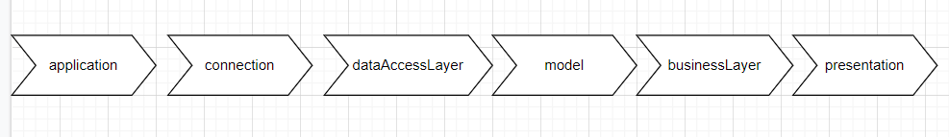
The packages for this application are grouped using the layered architecture. My application has the following packages:
Application: contains a single class that has the customary main() method.
BusinessLayer: it represents a package that contains methods used for the validation of the data that we are going to insert into the table, for example a name shouldn’t contain numbers.
Connection: it is the package where the connection with the database is made and contains only one class.
DataAccessLayer: it is the packages that contains the class where all the operations are made and also the table, build with reflection technique.
Model: in this package I formed the classes Client, Order and Product which correspond to the information in the tables of the database.
Presentation: this package is for the graphical interfaces: client view, order view, product view and the main view. I also added the controller that makes the switch between all these interfaces and a FileWriter class that helps us to write the details of the order in a text file.

Data structures: The data structures used in this project are mostly primitive types, especially integers and strings, but also complex types such as ArrayList type objects, Lists.
ArrayLists are easier to use in order to store more objects from the same class, like orders or clients or products, as here we work with more objects of these kinds.

The class diagrams are used in designing and modelling the software. The diagrams describe the classes and their relationships. They enable us to model software in a high level of abstraction and without having to look at the source code. The classes are described by including the attributes, objects and the methods from a specific class. On top we have the name of the class and below it the attributes. A minus in front of the attribute means that the attribute is private. The constructors, getters, setters and methods are listed below the attributes.
What are the benefits of UML diagrams? They are very flexible and easy to draw, and in this way, you can communicate the software architecture effectively.

The UML Diagrams:

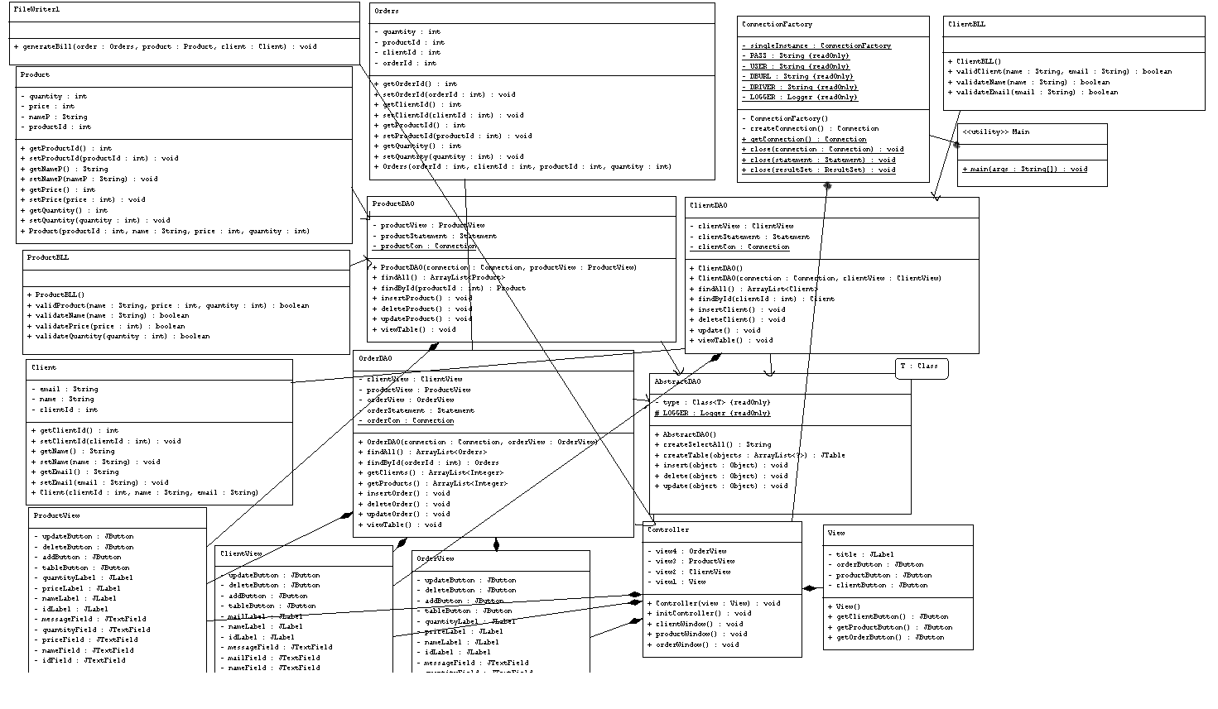

The DataBase tables:

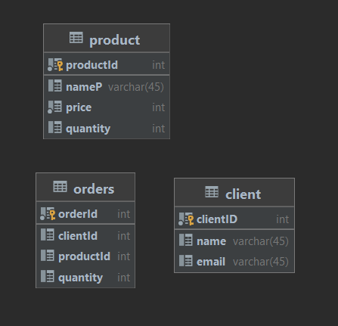

Graphical Interfaces:

Main Interface:

-it has three buttons in order to choose the next window that we want to open

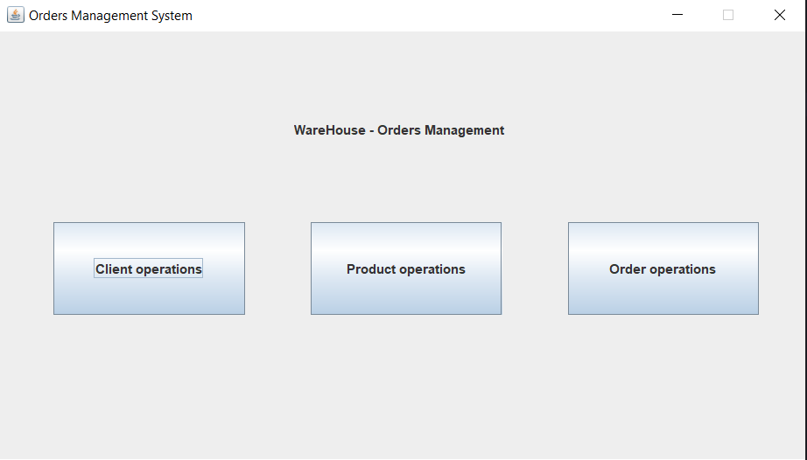

Client Interface:
-it has three fields for the details of a client
-4 buttons in order to do the operation that we want; the first one displays the table and updates it each time we change its details
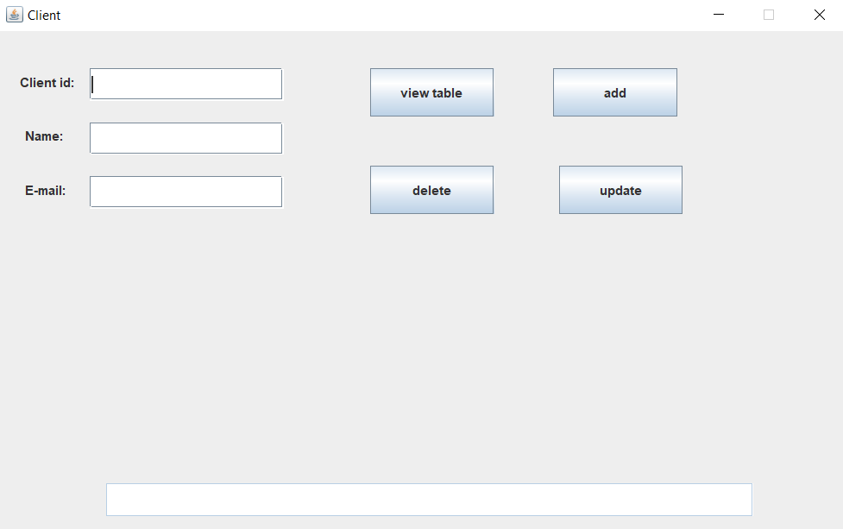

Product Interface:
-it has four fields for the details of the product
-4 buttons in order to do the operation that we want; the first one displays the table and updates it each time we change its details
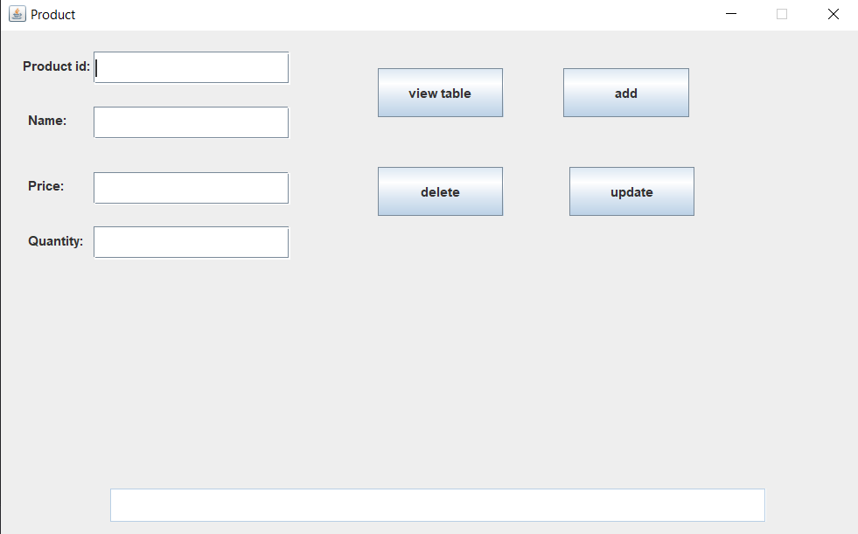

Order Interface:
-2 fields where we introduce the data
-2 combo boxes from which we select the client and the product
-4 buttons in order to do the operation that we want; the first one displays the table and updates it each time we change its details
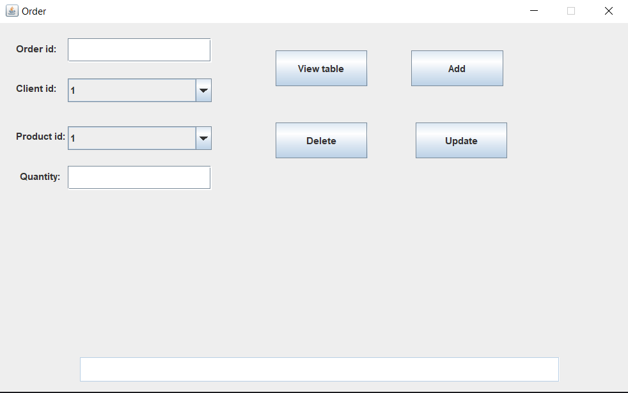

Implementation
The Main class has only one method, main, where we instantiate the view and initialize the controller, so
that the user can play with the application.
The ClienBLL and ProductBLL are classes used to validate the data that we introduce in our tables. They contain methods in order to validate the name of the client/product, the email address, the price and the quantity (they have to be integers that are greater than zero).
The ConnectionFactory class represents the class where we have our methods in order to connect to the database:
-we create a connection
-we close the connection
-we close the statement
-we close the result set
In the dataAccessLayer we have 4 classes that are very important. ClientDAO, ProductDAO and OrderDAO extend the class AbstractDAO so they we will use the methods implemented there in order to create queries and create a table. We have the following methods in the AbstractDAO:
-a method to create a query to select all the elements from the table
-a method to create the table
-a method to add an object
-a method to delete an object
-a method to modify an object
All these methods are implemented by using the reflection technique.
Example of the method creating a table:
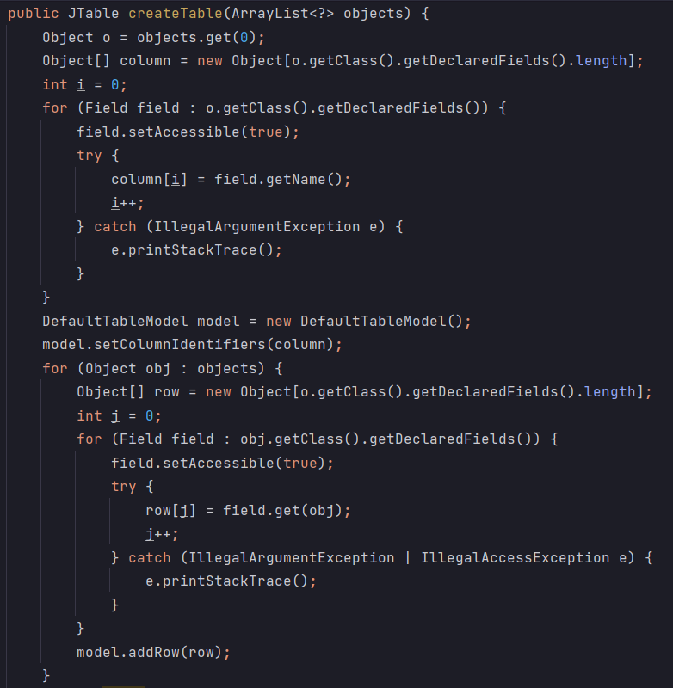

We get the names of the columns by using field.getName() and the actual data from each column by using field.get(obj) where obj is the object of type Object.
In the model package I have the classes Client, Orders and Product. They have to correspond with the tables that I created in my database and to have the same attributes as the tables there. They don’t contain any specific methods except the getters and setters.
In the last package, in the presentation I have the following classes:
- View class: here I designed the main graphical interface
- Controller class: here I described the relationships between the graphical interfaces and I added the action listeners in order to reach each interface easily
- FileWriter1 class: helped me in order to generate the text file with the bill
- ClientView class: here I designed the graphical interface for the client
- ProductView: here I designed the graphical interface for the product
- OrderView: here I designed the graphical interface for the order

Results
For the results I generated a text file where the details of a bill I displayed.
Also the results of each operation can be seen in the database tables and also in the tables generated on the graphical interfaces.

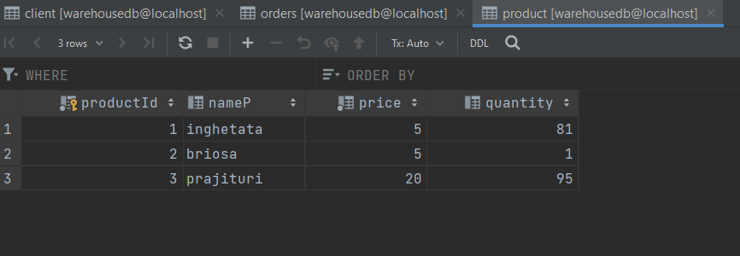
Showing the table on the graphical interfaces with all the orders that were made.

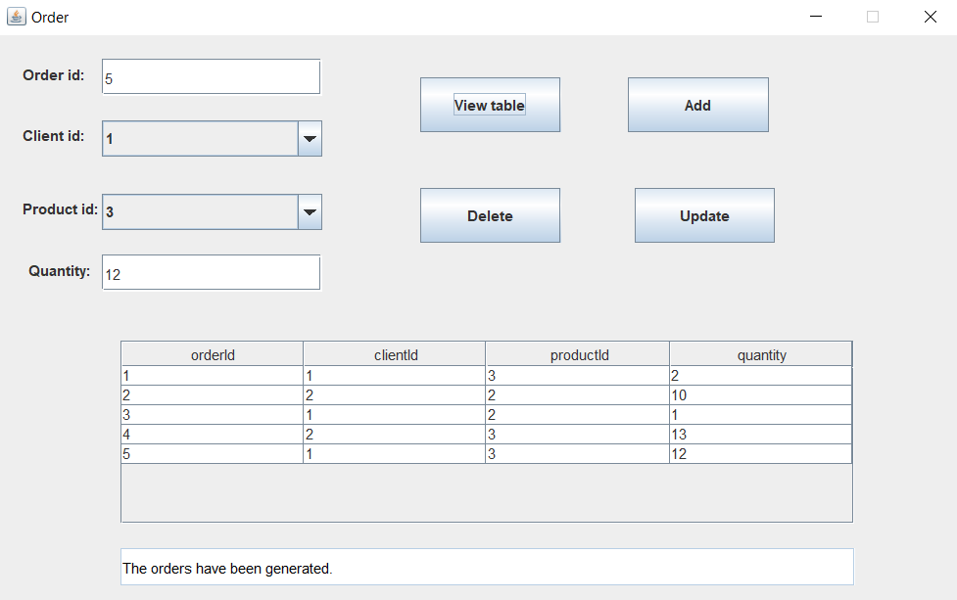

The bill.txt file:

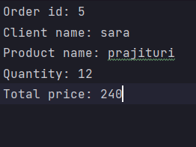

Conclusions
This project was a good exercise for improving OOP concepts and for improving the skills that I learned in the first semester of this year. I found it very challenging.
In the future, I would like to be more organized as I found out that having a good image of the project before starting to implement and write code and having the problem already organized in my mind and on paper helps a lot. It reduces time and work, and everything seems more clear and easier to work with. I also came to the conclusion that facing problems with your code and trying to solve them by yourself will obligate you to do a lot of research and you can learn better from it. After ending this project, I learnt how to connect a database to my application. I found it a little difficult at first, but as soon as I understood how it worked the code was written easily. I learned how to use the reflection technique in order to write queries and to generate the tables. I think that connection a database to the application represents a mandatory skill and it is very helpful when we need to store our data somewhere.

Bibliography

- Object Oriented Programming – lectures of prof. Marius Joldos
- Programming Techniques – lectures of prof. Cristina Bianca Pop
- www.stackoverflow.com
- Bro Code – YouTube channel
- https://www.baeldung.com/
- https://app.diagrams.net/

